Problem Frame

Students often never recover lost belongings, especially WatCards, while front desk staff lose track of items and donate ones that owners would have claimed. This is due to a sticky-note tracking system that staff can’t search or rely on, and the lack of a low-effort way for students to check, get notified about, and claim their items without approaching the front desk.

Staff: Front desk staff need an automatic way to track how long each item has sat at the desk, because sticky notes fall off and staff end up moving or donating items at the wrong time.
Who
- Front desk staff, who manage found items between other tasks and across shift changes
- Students who lose belongings, most often WatCards
What
Staff can’t reliably track how long an item has sat at the desk, and students can’t easily find out whether the desk has their item.
Where and when
At the building’s front desk: when staff hand off between shifts, when items move from Section A to Section B, and when students come looking, sometimes before staff have logged their item.
Root causes
- Paper tracking: dated sticky notes fall off, and staff can’t search the shift log quickly.
- Information stays at the desk: students have to show up and ask in person to learn anything.
- No link between lost and found: nothing connects a student looking for an item with the item once it arrives.
- Low awareness: many students don’t know REV has a lost and found at all.
Lost n Found: Primary research and user feedback

Interview: Ada (front desk worker at REV) - interviewed by lily
Current system:
- Student brings item to desk
- Worker reports in shift log
- Item gets placed in section A and marked with a date on sticky note
- Wallet/high value goes in safe
- Item moves to section B after two weeks - a month
- If not collected after a month, section B stuff gets donated
Issue with system
- Hard to tell how long item has been in lost n found (hard to keep track and sticky notes get lost and items get buried)
  - Items get moved to section b sometimes by mistake and lost
- Sometimes, people just don’t know abt lost n found/doesnt want to approach front desk
- Miscommunication with timing: item might arrive later or not sorted and person comes first
- Conclusion: not efficient system
User testing with idea
- Likes the idea because it is easier for communication
  - More efficient = more likely to use, less social anxiety for students
Notes:
- Most people lose wat cards

1. Waterloo-specific facts
WatCards cost students money to replace. The WatCard office charges $30 to replace a lost card, and students also have to report a lost WatCard to the Library so it gets deactivated there. So every unreturned WatCard costs a student $30 plus a trip to the WatCard counter and extra admin. uwaterloouwaterloo
Waterloo has many separate lost and found spots, each with different rules. UW’s Policy 20 lists more than a dozen counters, including Columbia Icefield, Dana Porter Library, Davis Centre Library, Food Services, the Physical Activities Complex, and the Student Life Centre, and it tells students to contact the counters in areas they recently visited, or Police Services. Rules also vary by location: Athletics keeps general articles for only two weeks, while the policy sets a minimum of 30 days for low-value articles and 60 days for most valuable articles. This backs up your finding that students don’t know where to look. Policy 20 – Lost and Found - Secretariat - University of Waterloo +3
A gap to ask Ada about. Policy 20 counts banking cards and identification documents as valuable articles, and says valuables turned in to a lost and found counter should go to Police Services as soon as practicable. A WatCard is an ID card, so REV keeping WatCards at the desk may not match official policy. Either way, it shows the rules are confusing even for staff. Your app could automatically route valuables correctly. uwaterloouwaterloo

2. How inefficient manual systems are
- Low return rates. Even large organizations with dedicated lost and found teams return only a fraction of items. Brussels Airport returned about 24% of lost items in 2024, and donated much of the rest. Sacramento’s airport returns about 35% of items to their owners. aircargoupdatesaccounty
- Staff waste time on manual searching. One software vendor describes how, without a database, staff have to physically search through piles of lost property when handling enquiries, which leads to long waits and time-consuming call-backs. That matches Ada’s description of items getting buried. service
- Schools don’t even know how many items they hold. When Old Dominion University adopted digital tracking, it found its actual inventory to be double its original estimate. 24-7pressrelease
- Academic research agrees. A 2023 study on campus lost and found systems found that existing university systems are inefficient because most students don’t know the exact places to check for their items. gaexcellence

3. How much a digital system can help
- Staff time: Crowdfind reports that staff at student unions and athletic facilities see up to a 50% reduction in time spent managing inquiries. A software comparison site estimates purpose-built tools cut the time staff spend documenting, searching for, and returning items by 40–60% compared to manual systems. 24-7pressreleasefitgap
- Return rate: At Virginia Tech, the student union reported a 100% increase in its return-to-owner rate after switching to a digital system in Fall 2016. At Seattle’s airport, staff using image-recognition software reunited 88% of lost items with owners in one month, far above the 24–35% rates above. 24-7pressreleasearcpublishing
- Speed matters: At Brussels Airport, 74% of returned items went back within two weeks. Fast notification is when returns happen, which supports your alert feature. airportindustry-news

4. The student’s side: lost time and stress
- People spend nearly 17 hours a year searching for lost items, about 16 minutes per item, according to a Shane Co. survey. kvia
- In a Pixie survey, 60% of people said they had been late to work or school because of lost items, and searches for wallets, IDs, and credit and debit cards often take more than 15 minutes. apartmenttherapyapartmenttherapy

5. A time-savings estimate you can use (fill in real numbers)
No source covers REV directly, so build your own estimate. Ask Ada for two numbers: how many items come in per week, and how many students ask about lost items per day.
Example with assumed numbers:
- Staff: 5 inquiries a day × 5 minutes each = 25 minutes a day. A 50% reduction saves about 12 minutes a day, or about 1.5 hours a week per desk.
- Students: if 10 WatCards a month go unreturned, students pay $300 a month in replacements ($30 × 10).

Features:

Overview:
Visual browse grid: photo cards sorted by category (WatCards, keys, bottles, clothing, electronics), so students recognize their item at a glance instead of reading descriptions.
→ home page dashboard
—> filter also by location (building) and date
→also ai search so you can input details like blue waterbottle and picture gets matched, or shows no results

When clicked into item:
→shows all details

Campus map view: pins show which desks hold items, with hours and directions. This solves “I don’t know where to look.”

Cut the anxiety
- No-account first search: let students browse without signing in. Ask them to log in with their UW account only when they claim something.
- Claim in three taps: pick the item, answer one ownership question, get a pickup code. Fewer steps means more students finish.
- Pickup code or QR: students show a code at the desk instead of explaining what they lost. This directly targets the social anxiety Ada mentioned.
Informed:
“Notify me” button: if a search finds nothing, students save a short description and get an email or push alert when a match appears. This fixes the “I came too early” timing problem.

Staff side:

Photo-first logging: snap a photo and the app suggests the category and colour. Staff confirm instead of typing → directly creates an id/code for the item
- Logs date so can keep track of how long its been there for
- Colour-coded age: green (new), yellow (move soon), red (ready to donate). Staff see what needs action without reading dates.
- Daily to-do list: “3 items to move, 2 pickups waiting, 1 claim to approve.” This replaces guesswork during shift changes.
- Activity log: records who logged, moved, or released each item, so shift handoffs don’t lose information.

- Valuables flag: WatCards, wallets, and phones get a lock icon and a prompt to store them securely or send them to Police Services, which matches UW’s Policy 20.
- Hidden details: students see “black wallet,” never a photo showing the cards inside, so nobody can fake a claim.

Features across both sides
- WatCard auto-return: staff enter the name on the card/takes photo of wat card, and the app emails the owner.
- Mobile-first web app: students use phones, and staff may use a desk computer or tablet. Design for phone screens first.
- Privacy by design: show only first names or initials on public listings, and delete claim data after pickup.

The student staff dual portal is really interesting what is the difference between the two portals

How it works
The idea is simple: the app records the exact moment staff log an item, then calculates its age every day. Nobody has to write or read a date.
- Timestamp on logging: when staff log an item, the app saves the date and time automatically, along with the category and storage spot.
- Rules per category: each type of item gets its own timeline. For example:
  - Low-value items (clothes, bottles): move to long-term storage at 14 days, ready to donate at 30 days
  - Valuables (WatCards, wallets, phones): flagged for secure storage right away, kept at least 60 days
- These match UW’s Policy 20 minimums, and each desk can adjust them.
- Daily check: once a day, the app compares each item’s age to its rules and updates its status: New → Move soon → Ready to donate.
- Alerts and to-do list: staff see a list at the start of each shift, like “3 items to move, 1 ready to donate.” Students who saved a matching alert or claim get a reminder, like “Your item leaves in 5 days.”
- Scan to confirm moves: each item has a QR label. When staff move it, they scan the label. If the item isn’t due yet, the app warns them, which prevents the “moved to Section B by mistake” problem.

The process, start to finish
Step | Old way (sticky notes) | With auto-aging
Item arrives | Staff write the date on a sticky note | App timestamps it automatically
Days pass | Note falls off, item sinks into the pile | App tracks the age in the background
Time to move | Staff guess, sometimes too early | App flags it, staff scan to confirm
Time to donate | Staff sort through Section B by hand | App generates a donation list
Student asks | Staff dig through piles | Staff search the app, or the student checks online

Impact
For staff
- No more sticky notes or guessing: the app remembers dates, so shift changes don’t lose information.
- Fewer mistakes: scan-to-confirm stops items from moving or getting donated at the wrong time.
- Less time sorting: a ready-made to-do list replaces digging through shelves. Lost and found software vendors report that digital tracking cuts the time staff spend documenting, searching for, and returning items by roughly 40–60%.
For students
- Items stay available for the full time: no more donations before an owner has a fair chance to claim.
- Countdown creates urgency: a “leaves in 5 days” reminder pushes students to pick up their stuff.
For the university
- Policy compliance: the app enforces the minimum holding periods automatically.
- Real data: desks finally know how many items they hold and how long they sit. When Old Dominion University started tracking digitally, it found its inventory to be double what it had estimated.

How to measure it
To prove the impact in your project, compare before and after on:
- Number of items moved or donated by mistake
- Minutes staff spend per shift sorting or searching
- Percentage of items returned to owners
- Average days an item sits before pickup

Lost link
- Scan all items at once n ai categorizes each item
- Compares to student reported lost item report

Path A: WatCard (student does nothing)
- A staff member logs a found WatCard and enters the name on it or takes photo and ai automatically reads it.
- The app emails the student right away: “Your WatCard is at the DC Library desk. Tap here to claim it.”
- The student taps the link and lands straight on the claim screen, skipping search entirely.

Path B: Search and find it
- Open the app: the student scans a QR poster or follows a link. No sign-in needed to browse.
- Search or browse: they pick a category (e.g. “Bottles”) and filter by building and date (“DC, Tuesday”). Results show as a photo grid.
- Spot their item: they tap the card to see the desk location, desk hours, and how long the item stays before donation.
- Start a claim (see claim steps below).

Path C: Not there yet
- The student searches and finds nothing, often because staff haven’t logged it yet.
- They tap “Notify me” and fill out a short form: category, colour, brand, where and when they lost it.
- When staff log a similar item, the app sends an alert: “A blue Hydro Flask turned up at the SLC desk. Is this yours?”
- The student taps the alert and goes to the claim screen.
Claim and pickup (all paths)
- Sign in with UW account: only at this point, so the app knows who’s claiming and can contact them.
- If valuable, answer an ownership question: for example, “What’s inside the wallet?” Public listings never show these details, so others can’t fake a claim.
  - Wait for approval: staff review the answer, usually within the shift. A status tracker shows Claim sent → Approved → Ready for pickup.
- If not valuable, claim instantly: the student taps “This is mine” and gets a pickup code right away. The app marks the item as reserved so no one else can claim it, and holds it for a few days. Students can optionally add a detail (e.g. “size M, small stain on the cuff”) to help staff confirm at pickup.
- Get a pickup code: once approved (valuables) or instantly (non-valuables), the student receives a code or QR, plus the desk location and hours.
- Pick up: they show the code at the desk, staff scan it, and the item’s record closes. No explaining needed, though students can always go straight to the desk and ask if they prefer.
Safeguards for instant claims
- UW sign-in creates accountability: the app records who claimed each item, which discourages taking things that aren’t yours.
- One claim per item: once reserved, the item disappears from available listings.
- Two claims, staff decide: if a second student says the item belongs to them, the claim switches to staff review.
- Claim limits: cap instant claims per student (e.g. 3 per week) to stop anyone collecting free hoodies.
- Expiring reservations: if the student doesn’t pick up within the hold period, the item goes back on the list.

Reminders along the way
- If an approved item sits uncollected: “Your item leaves the desk in 5 days.”
- If a student’s “Notify me” request finds no match after a while, the app suggests other desks to check or lets them extend the alert.

Path D: Student finds an item
- Report it: the student taps “I found something” (no sign-in needed). They snap a photo, and the app suggests the category and colour, then records the time and their location automatically. The student just confirms the building or room (“DC, 2nd floor study area”).
- Choose what to do with it. The app suggests the best option based on the item:
  - Drop it at a desk (default): the app shows the nearest open desk with directions and hours.
  - WatCard: the student types the name on the card, the app notifies the owner, and the student drops it at the nearest desk.
  - Valuables (wallet, phone, laptop): the app tells them to bring it to a staffed desk or Campus Police, following UW Policy 20. No meetups with strangers.
- “In transit” status: as soon as the student reports the item, it appears in the app as “On its way to the SLC desk.” If the owner searches or has a “Notify me” alert, they find out right away, even before the item reaches the desk. This fixes the timing gap from your interview.
- Drop-off: the student shows a drop-off code at the desk. Staff scan it, and the photo, location, and time already fill in, so staff only add the storage spot. Logging takes seconds, and the auto-aging timer starts.
- Thank-you: once the owner picks it up, the finder gets a notification: “The owner picked up the water bottle you found. Thanks!” You could add optional rewards, like points or campus perks.

Why this design works
Research finding | How the student flow responds
Students don’t know where to look | One search covers every desk, with a map and hours
Students avoid the front desk | Claim online, pick up with a code
Students arrive before their item | “Notify me” alerts them when it arrives
WatCards are the most common item | Auto-return email, no search needed
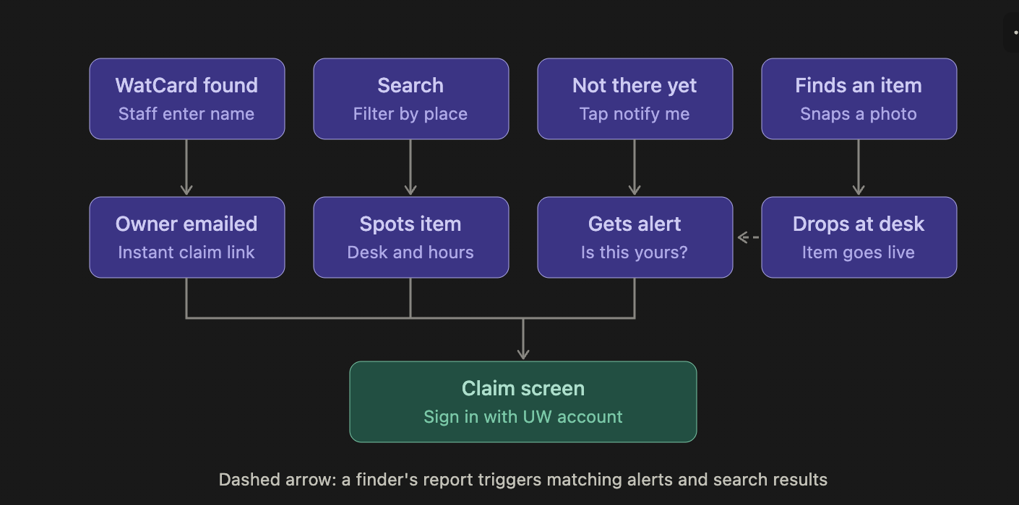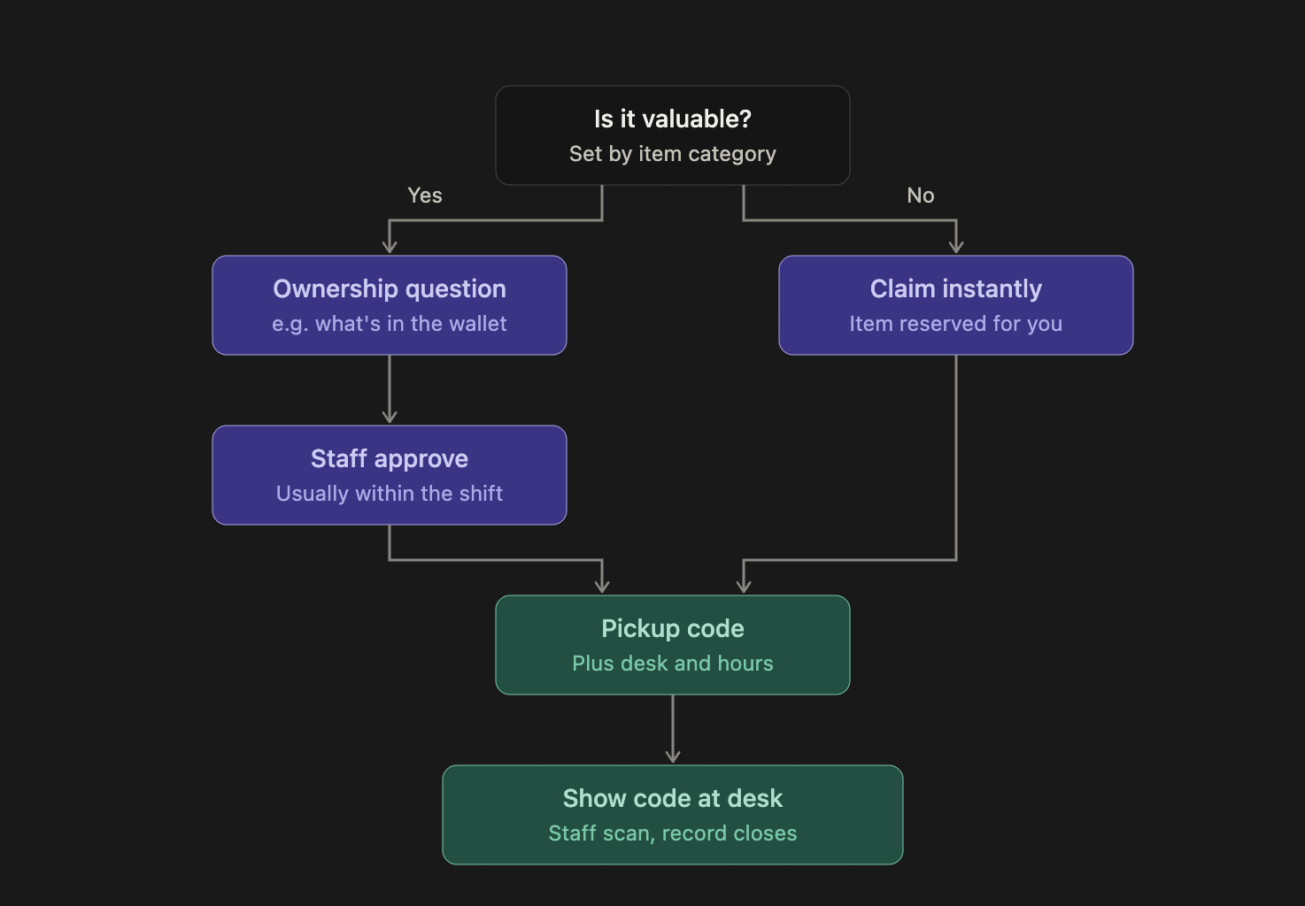
Build a mobile-first web app called "FoundIt", a campus lost and found platform for University of Waterloo students and staff. This is a clickable prototype for a student design project, so use mock data and local state only (no real backend, no real emails, no real sign-in).

Roles
Add a toggle at the top to switch between "Student view" and "Staff view" so we can demo both sides. Fake the UW sign-in with a button that signs in as a sample student ("Lily Lu, lily.lu@uwaterloo.ca").

Mock data
Seed about 15 found items across these campus desks: SLC front desk, DC Library, Dana Porter Library, PAC equipment desk, REV front desk. Each item has: photo placeholder, category (WatCard, keys, bottle, clothing, electronics, wallet, other), colour, short public description, desk, date logged, status, and a "valuable" flag (WatCards, wallets, phones, laptops are valuable). Vary the dates so some items are new, some are 14+ days old, and some are 30+ days old.

Student view
- Home: big search bar, category chips, and three buttons: "Find my item", "I found something", "My claims".
- Search and browse: photo grid of items, with filters for category, building, and date. No sign-in needed to browse. Valuable items show only a generic description (e.g. "black wallet"), never identifying details.
- Item detail: desk location, desk hours, how many days until the item leaves the desk, and a "This is mine" button.
- Notify me: if search finds nothing, show a "Notify me" form (category, colour, brand, where and when lost). Save it, and when staff later log a matching item, show an in-app alert: "Is this yours?"
- Claim flow (require sign-in here):
  - Valuable item: ask one ownership question (e.g. "What's inside the wallet?"), then show status "Claim sent → Approved → Ready for pickup". Staff approve it in Staff view.
  - Non-valuable item: claim instantly. Reserve the item, hide it from other students, and give a pickup code right away. Optional field: "Add a detail to help staff confirm (e.g. size, stains)".
  - If a second student claims an already reserved item, send it to staff review.
  - Limit instant claims to 3 per week per student.

- Pickup code screen: large QR code plus a 6-character code, desk name, desk hours, and hold expiry date.
- I found something: photo upload, category, colour, location found (building + room). Then suggest the nearest open desk. If the category is WatCard, ask for the name on the card and show a confirmation "We notified the owner." If the item is valuable, tell the student to bring it to a staffed desk or Campus Police. After reporting, the item appears in search as "In transit to [desk]" and triggers any matching Notify me alerts. Give the finder a drop-off code.
- Inbox: in-app notifications in place of emails (WatCard found, match alerts, claim approved, "Your item leaves in 5 days", finder thank-you).

Staff view
- Dashboard: today's to-do list ("3 items to move, 2 pickups waiting, 1 claim to approve") and counts by status.
- Log item: photo-first, big tap targets, minimal typing. Pick category, colour, storage spot. The app timestamps the item automatically. For WatCards, staff type the name on the card and the app sends the owner a notification.
- Inventory list with automatic aging: colour-code every item by age. Green = under 14 days, yellow = 14–29 days (move to long-term storage), red = 30+ days (ready to donate). Valuables show a lock icon and stay for at least 60 days.
- "Mark as moved" with a warning if the item isn't due yet.
- Claims queue: approve or reject valuable claims and contested claims.
- Scan pickup or drop-off code: a text field where staff enter a code to close a pickup or accept a finder's drop-off (which pre-fills the item details).

Design
Clean, friendly, and modern. Use a gold and black accent palette inspired by Waterloo, white backgrounds, rounded cards, clear status pills, and plenty of spacing. Make it look good on a phone screen first, and keep every main action reachable in one or two taps. Use plain, friendly microcopy.

Create a mock student sign-in flow for the FoundIt app. Include a button that, when clicked, simulates a successful sign-in for 'Lily Lu' with the email 'lily.lu@uwaterloo.ca'. After sign-in, update the UI to reflect the logged-in state and enable access to student-specific features.

Add a UI element, such as a toggle or dropdown, at the top of the FoundIt app that allows switching between 'Student View' and 'Staff View'. Ensure that when 'Student View' is active, the student-specific features are displayed, and when 'Staff View' is active, the staff-specific dashboard and functionalities are shown.

Generate mock data for approximately 15 lost items for the FoundIt app. Distribute these items across the following desks: SLC front desk, DC Library, Dana Porter Library, PAC equipment desk, and REV front desk. Each item should have a photo placeholder, a category (WatCard, keys, bottle, clothing, electronics, wallet, other), a colour, a short public description, the desk it was logged at, a logged date (varying from new to over 30 days old), a status (e.g., 'At Desk', 'Claimed'), and a boolean 'valuable' flag (true for WatCards, wallets, phones, laptops).

Lost n found
- Can be optimized def

Efficiency

Catergorize things ike chargers and calculators
Unless direct match

Good feasability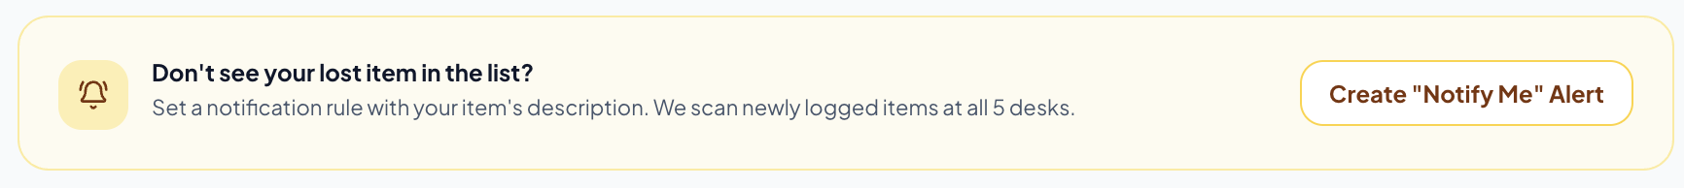
We like this, move to top next to lost n found smt, also ai photo scanner option
Nearest loc

Add capture

Push email for notify me stuff for match

Add guide- screen gets highlighted

Map on specific item for location

Map generally for categories of things, like where lost and found is located

FoundIt: AI-Powered Campus Lost & Found Platform
Build a polished, mobile-first web application called FoundIt, an AI-powered lost and found platform designed for University of Waterloo students and staff.
The goal is to make recovering lost belongings effortless by using AI image recognition, automatic matching, student-generated return codes, and a centralized campus-wide lost and found system.
This is a clickable prototype for a student design project. Use realistic mock data, interactive UI, and local state. Do not require a real backend, actual email delivery, or real university authentication. All major features should be functional in the prototype.

1. Design and Visual Identity
Create a beautiful, modern, premium-looking interface.
Colour palette:
- Warm beige, ivory, and linen backgrounds.
- Soft cream cards and subtle sandstone borders.
- Muted caramel, warm brown, and amber accents.
- Dark charcoal typography.
- Minimal use of gold for important actions and status indicators.
Avoid overly saturated colours, excessive gradients, or a generic dashboard appearance.
The design should feel welcoming, intuitive, and trustworthy. Use:
- Rounded cards and subtle shadows.
- Beautiful typography and clear visual hierarchy.
- Generous whitespace.
- Smooth transitions and subtle animations.
- Large, accessible buttons.
- Responsive layouts optimized for mobile first, while looking equally polished on desktop.

2. Two Separate Systems: Student and Staff
Include a prominent toggle at the top of the application to switch between:
- Student View
- Staff View
These must function as two distinct portals with different dashboards, navigation, and permissions.
Simulate University of Waterloo sign-in with a button that logs in as:
Lily Lu
lily.lu@uwaterloo.ca
Browsing should not require sign-in. Require simulated authentication for student-specific features such as saving reports, generating return codes, and claiming items.

3. First-Time Interactive Tutorial
On the first page visit, display a beautiful, interactive onboarding tutorial.
The tutorial should explain the application through a guided walkthrough with highlighted interface elements.
Important: Implement actual guided highlighting.
When a tutorial step begins:
- Dim the rest of the interface.
- Highlight the specific button, card, navigation tab, or feature being explained.
- Display a floating tooltip with a short explanation.
- Include Next, Back, Skip, and Finish buttons.
- Automatically move to the next highlighted feature when the user clicks Next.
Include steps explaining:
- How to report a lost item.
- How to upload a found item and use AI photo scanning.
- How automatic AI matching works.
- How to generate personal return tags.
- How to use the campus map.
- How students receive notifications.
- How staff manage inventory and approve claims.
Add a Guide button in the navigation so users can reopen the tutorial whenever they want.

4. AI-Powered Image Recognition and Matching
This should be the central feature of FoundIt.
The system should use an AI-style image recognition simulation to identify found items and automatically match them against previously submitted lost-item reports.

AI Photo Scanner
Make the photo scanner a prominent feature on the homepage, positioned near the main Lost & Found functionality.
Allow users to:
- Upload a photo from their device.
- Take a photo directly using their phone camera.
- Scan an image to identify an item.
- See an animated scanning process.
- View automatically generated item characteristics.
The scanner should identify:
- Item category and subcategory.
- Primary and secondary colours.
- Brand or manufacturer, if recognizable.
- Shape, material, and approximate size.
- Distinctive features such as stickers, scratches, logos, patterns, and accessories.
Generate a structured AI description.
For the prototype, simulate AI analysis using mock results and deterministic matching logic if no actual AI service is available. Do not pretend a real AI model is connected.

Smart Automatic Matching
Automatically compare found items against all existing lost reports.
Matching should consider:
- Category.
- Colour.
- Brand.
- Distinctive features.
- Description similarity.
- Photo similarity (simulated).
- Date and location.
Give distinctive features more weight than generic similarities.
For example, two black water bottles should not be considered a strong match simply because they share the same colour and category. A matching sticker, scratch, or unique design should substantially increase the confidence score.
Display ranked potential matches with:
- Found item photo.
- Lost report photo.
- AI-generated descriptions.
- Match confidence percentage.
- Matching characteristics.
- Differences between the two items.
- Report date and location.
Provide a clear action to confirm or reject a potential match.
When a strong match is identified, trigger an in-app notification to the potential owner.

5. Smart Categorization and Search
Make the browsing experience efficient and easy to navigate.
Automatically categorize items into:
- WatCards and ID cards.
- Keys.
- Bottles.
- Clothing.
- Electronics.
- Wallets.
- Bags and backpacks.
- Calculators and school supplies.
- Other.
Allow users to filter by category, colour, building, date, and status.
Important: Add intelligent categorization.
For example, chargers, calculators, headphones, and other electronics should be grouped into useful subcategories rather than appearing as completely unrelated items.
If there is a direct AI match, prioritize that result. Otherwise, suggest related items within the same category.
Include:
- A large search bar.
- Category chips.
- Recent listings.
- Potential matches.
- Nearby lost and found desks.
Valuable items such as wallets, WatCards, phones, and laptops should never expose identifying personal information in public listings.

6. Student Portal
Create a dedicated student dashboard with the following features.

Homepage
Include:
- Prominent search bar.
- AI Photo Scanner.
- Report a Lost Item.
- Upload a Found Item.
- My Lost Reports.
- Potential Matches.
- My Return Tags.
- Notifications.
- Campus Map.
The most important features should be reachable within one or two taps.

Report a Lost Item
Students should be able to:
- Upload a reference photo.
- Enter an item name and description.
- Select a category and colour.
- Enter brand and distinctive characteristics.
- Select the building and specific room or location where they lost it.
- Enter the approximate date and time it was lost.
- Add additional identifying details privately.
After submission, display a confirmation and add the report to My Lost Reports.

My Lost Reports
Display all active and resolved reports.
Each report should show:
- Photo.
- Item details.
- Date and approximate time lost.
- Building and location.
- Current status.
- Potential AI matches.
- Timeline of updates.

My Potential Matches
Show all possible matches generated by the AI.
Allow students to review the found item and confirm whether it belongs to them.

My Return Tags
Allow every student to generate their own unique personal return code and QR code.
Examples:
- WAT-7842
- WAT-3190
- WAT-5521
Students can generate tags for their:
- Water bottles.
- Laptops.
- Calculators.
- Headphones.
- Backpacks.
- Keys.
- Other belongings.
Allow them to download or print their tags as stickers.
When someone finds a tagged item and scans or enters the code:
- Identify the registered owner.
- Generate an immediate in-app notification.
- Provide a secure way to arrange the return.
- Keep the owner's personal information private.
Include a Simulate Finder Scan button to demonstrate this process.

Notifications
Create an in-app notification centre with:
- Potential AI match alerts.
- Someone scanned your return tag.
- Your item has been found.
- Claim approved.
- Item ready for pickup.
- Reminder that an item is approaching its storage deadline.
Simulate push and email notifications visually, but do not send actual emails.

7. Report a Found Item
Make this an extremely simple, photo-first process.
A student or finder should be able to:
- Upload or take a photo.
- Let AI identify the item.
- Confirm the generated category and description.
- Enter the location and date found.
- Select the nearest staffed lost and found desk.
- Submit the report.
After submission:
- Generate a unique drop-off code.
- Display the recommended desk.
- Show directions to the desk.
- Update the item status to In Transit or Awaiting Drop-off.
- Trigger any relevant matching notifications.
If a return tag is detected, prioritize direct owner notification.
For valuable items, recommend taking them directly to a staffed desk or Campus Police.

8. Campus Map and Location Features
Create an interactive University of Waterloo campus map.
This is an important feature and should be visually prominent.

Campus-wide Map
Display:
- All participating lost and found desks.
- Buildings with active lost reports.
- Buildings with found items.
- Locations with high numbers of lost items.
- Nearest lost and found desk.
Use different pin styles or colours to distinguish lost reports, found items, and staffed desks.

Building-Specific Maps
Allow users to click on a building and view its dedicated lost and found information.
For example:
- SLC.
- Dana Porter Library.
- DC Library.
- E7.
- PAC.
- REV.
- Other campus buildings.
When a building is selected, show:
- Number of active lost reports.
- Number of found items.
- Items currently held by that building's desk.
- Desk location and operating hours.
- A map of relevant reports within that building.
Staff should have access to the map for their own building and be able to view the location history of items.

Nearest Desk Recommendation
When a student reports finding something, automatically suggest the nearest open staffed desk based on the selected campus location.
Display:
- Desk name.
- Distance or estimated walking time (mock data).
- Operating hours.
- Directions.

9. Item Timeline
Create a chronological timeline for every item.
For students, show:
- When the item was reported lost.
- When a matching found item was uploaded.
- When AI identified a potential match.
- When the owner was notified.
- When the claim was submitted.
- When the item was approved.
- When it was picked up.
For staff, show:
- When the item was received.
- When it was entered into inventory.
- Which desk received it.
- Where it was stored.
- When it was moved.
- When a claim was submitted.
- When it was released.
Make timelines visual, easy to understand, and filterable.

10. Claims and Pickup
Implement a simulated claim workflow.
Non-valuable items:
- Allow instant claims.
- Generate a six-character pickup code.
- Hide or reserve the item from other students.
- Include an optional field for identifying details.
- Limit instant claims to three per week per student.
Valuable items:
- Require one private ownership-verification question.
- Send the claim to the staff approval queue.
- Do not reveal the correct answer publicly.
- Display statuses: Claim Submitted → Approved → Ready for Pickup.
If a second student attempts to claim an already reserved item, flag it for staff review.

Pickup Code Screen
Show:
- Large QR code.
- Six-character pickup code.
- Item details.
- Pickup desk.
- Desk hours.
- Hold expiry date.
Staff should be able to scan or enter the code to complete the handover.

11. Staff Portal: Inventory Management System
The staff portal should function as a separate inventory management system.
Staff should only manage their assigned building or desk, with an option for authorized administrators to view all locations.

Staff Dashboard
Show:
- Today's to-do list.
- Items awaiting intake.
- Items awaiting matching review.
- Claims requiring approval.
- Pickups waiting.
- Items approaching storage deadlines.
- Inventory counts by status.
Example:
- 3 items to move.
- 2 pickups waiting.
- 1 claim to approve.

Log a Found Item
Make this photo-first with minimal typing.
Allow staff to:
- Upload or capture a photo.
- Use AI photo scanning.
- Confirm category, colour, and description.
- Enter distinctive characteristics.
- Assign a storage location or locker number.
- Automatically record the date and time.
- Link the item to potential lost reports.
For WatCards, staff can privately enter the name on the card to facilitate owner notification.

Inventory Management
Create a searchable inventory table and card view.
Each item should display:
- Photo.
- Item category.
- Description.
- Date received.
- Time in storage.
- Storage location.
- Building.
- Status.
- Valuable flag.
- Potential matches.

Automatic Aging System
Use the following colour coding:
- Green: Under 14 days.
- Yellow: 14–29 days, ready to move to long-term storage.
- Red: 30+ days, eligible for donation or disposal according to applicable policy.
Valuable items must be flagged with a lock icon and retained for at least 60 days.
Add warnings before staff move or dispose of items that are not yet eligible.

Claims Queue
Staff should be able to:
- Review valuable item claims.
- Review disputed claims.
- View private ownership-verification responses.
- Approve or reject claims.
- Mark approved items as ready for pickup.

Scan Codes
Add a staff interface to scan or manually enter:
- Student pickup codes.
- Finder drop-off codes.
- Student return tag codes.
The system should update the inventory automatically when an item is received or picked up.

12. Mock Data
Seed approximately 15 realistic found items distributed across:
- SLC front desk.
- DC Library.
- Dana Porter Library.
- PAC equipment desk.
- REV front desk.
Include a mix of:
- WatCards.
- Keys.
- Bottles.
- Clothing.
- Electronics.
- Wallets.
- Calculators.
- Other belongings.
Each item should contain:
- Photo placeholder.
- Category and subcategory.
- Colour.
- Public description.
- Private identifying details where applicable.
- Desk and building.
- Date and time logged.
- Current status.
- Valuable flag.
- Storage location.
- Timeline events.
Vary the dates to demonstrate new items, 14+ day items, and 30+ day items.
Also seed mock student lost reports, AI matches, notifications, claims, and return tags so the entire application can be demonstrated immediately.

13. Navigation and Functionality
Use clear navigation that changes based on the active portal.
Student navigation:
- Home.
- Browse.
- Report Lost.
- Found Something.
- My Reports.
- Return Tags.
- Campus Map.
- Notifications.
Staff navigation:
- Dashboard.
- Inventory.
- Log Item.
- Claims.
- Campus Map.
- Timeline.
- Scan Codes.
Every primary button, filter, toggle, card, tab, and modal must work.
Use local state to demonstrate the full flow:
- Reporting an item creates a new report.
- Uploading a found item triggers simulated AI analysis.
- Matching generates ranked results.
- Matches trigger notifications.
- Claims update item statuses.
- Staff approval updates student dashboards.
- Pickup codes close inventory records.
- Return tag scans notify the registered owner.
Do not leave buttons as decorative elements.

14. Final Product Priorities
Prioritize these features in development:
- AI Photo Scanner and Automatic Matching: The core differentiator of FoundIt. Make it prominent and easy to use.
- Separate Student and Staff Systems: Both portals must have distinct and functional workflows.
- Interactive Campus Map: Show lost and found reports by building, staffed desks, and nearby locations.
- Student Return Tags: Unique QR codes that directly connect found belongings to their registered owners.
- Guided Tutorial: A first-visit walkthrough that highlights actual interface elements.
- Staff Inventory and Aging: Make managing, tracking, and recovering items efficient.
- Item Timelines and Notifications: Give both students and staff visibility into every stage of the recovery process.
The finished application should feel like a real, thoughtfully designed university product, not a generic administrative dashboard.
Most importantly, prioritize usability and efficiency. A student should be able to report a lost item or upload a found item in under a minute. Staff should be able to log, categorize, and locate an item with minimal manual input. The AI should reduce manual browsing and repetitive administrative work as much as possible.
Build the complete clickable prototype with polished mock data and realistic interactions.

